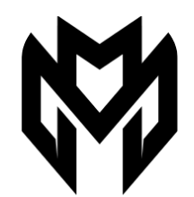
MARLON

Marlon originates from the tropics of his Traditional lands of the Larrakia in Darwin, Northern Territory. Transitioning from a Professional AFL Career being drafted at the age of just 17, Marlon’s transformation into singer songwriter has catapulted into co-writing songs with Australian Hip Hop stars such as Urthboy, ‘YES’ with Rap/Hip Hop Powerhouse A.B Original, ‘Blak Australia Policy from the ARIA award winning Album of 3%, and most recently the smash hit ‘The Gift’ with Rap Giants Hilltop Hoods.

Marlon blends his early music influences of Michael Jackson with and more recent sounds like Miguel, Weeknd and N.E.R.D to produce thought provoking, melodically moving lyrics with his captivating voice, challenging the status quo and capturing the story of his ancestral homelands, and the challenges of Aboriginal Australia.

Coming off consecutive National tours supporting Australian Artists Xavier Rudd and Pete Murray in 2022, and 2023 and a NIMAS nomination for Best Emerging Talent, Marlon is preparing himself for a gigantic 2025 campaign set to release his debut single ‘Blood in the Water’ from his debut Album.

